EX NO 13: Counting Alphabetic Characters and Digits Using LEX

Aim:
To write a LEX program to count the total number of alphabetic characters and digits in a given input file.
Algorithm:
- Start the program.
- Initialize the alphabetic character and digit counters to zero.
- Read the input file character by character.
- Increment the alphabetic counter for letters A–Z and a–z.
- Increment the digit counter for digits 0–9.
- Display the total number of alphabetic characters and digits.
- Stop the program.

Program:

%{
#include <stdio.h>
int alphabets = 0, digits = 0;
%}

%%
[A-Za-z] { alphabets++; }
[0-9] { digits++; }
.|\n ;
%%

int main()
{
yylex();
printf("Total alphabetic characters = %d\n", alphabets);
printf("Total digits = %d\n", digits);
return 0;
}

int yywrap()
{
return 1;
}

Sample input:
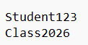
Sample output:
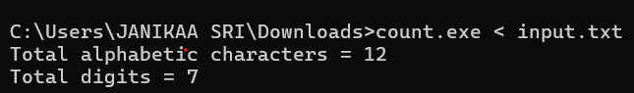

Result:
The LEX program was executed successfully and counted the total number of alphabetic characters and digits in the given input file.

